Template: Muddy City 2.0 Contributions

Complete the portions in blue about Version 2.0 of the Muddy City Lesson Plan.

## 1. Glossary Words

Identify at least 3 vocabulary words and create appropriate definitions that students will either a) need to know or b) learn in this lesson plan. A good definition matches the "level" of the lesson and directly applies to the specific usage in the lesson. Mark each either "Expected" or "Learned".

*If you use or slightly modify a specific source, please cite by linking to it.*

| **Word** | **Definition** | **Expected or Learned?** |
| --- | --- | --- |
| Nodes/Vertices | Nodes/vertices represent an object and are represented by a circle | Expected |
| Edges | Edges connect two vertices/nodes and may or may not have a weight/cost assigned to them | Expected |
| Graph | A data type that consists of nodes/vertices and edges to model a situation or a problem | Expected |
| Path | A series of connected edges that you take to travel from one node/vertex to another | Learned |
| Shortest path | A path that contains the shortest total cost or weight from one node/vertex to another | Learned |
| Spanning tree | A subset of a graph such that it connects all nodes/vertices using the smallest amount of edges possible | Learned |
| Minimum spanning tree | A spanning tree such that the total costs/weights of the edges are as small as possible | Learned |

## 2. Assessment Item

Create one assessment item (e.g. quiz question) that students should be able to answer after the lesson plan. The assessment item should address one of the given learning outcomes. NOTE: You must create both the question AND the answer (or a sample one if there's more than one).

**Learning Outcome Addressed:** Find a minimal spanning tree (least cost paving) from a diagram or graph

**Assessment Item:** Find the minimum spanning tree of the graph below.

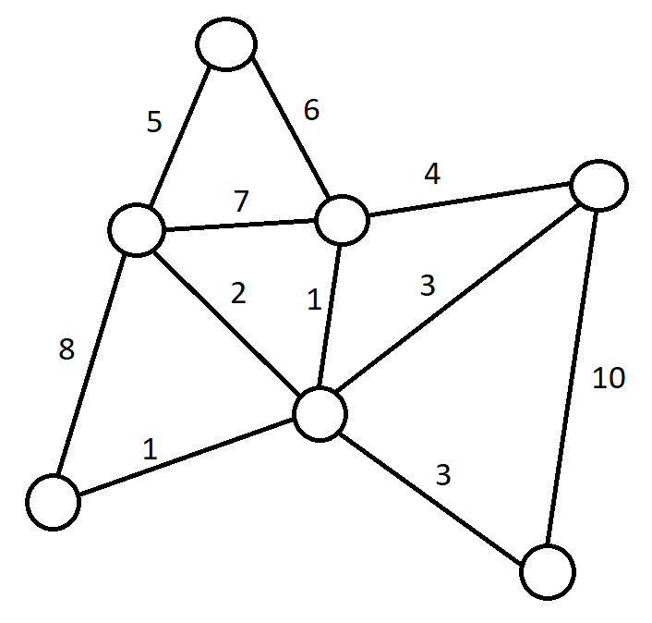

**Answer or Sample Answer:**

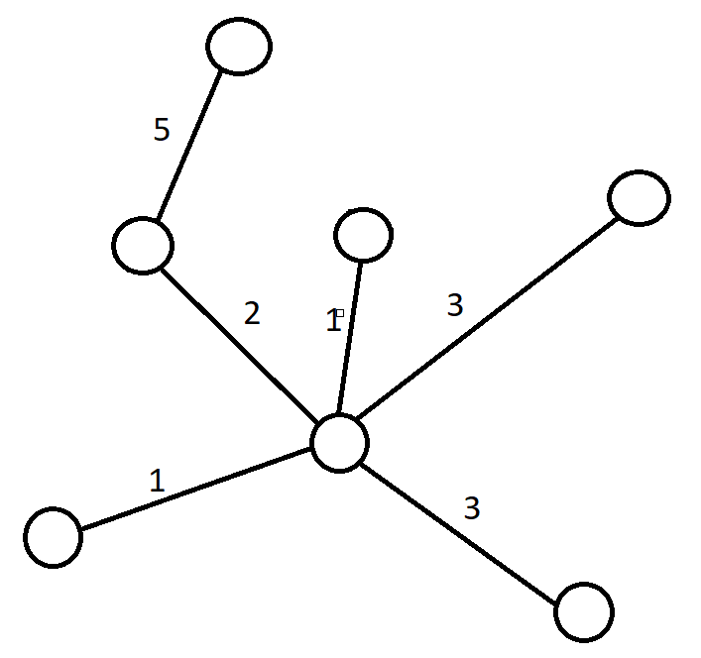

## 3. Lesson Plan Difference Analysis

Describe in your own words the key differences between the original and the modified Muddy City lesson plans. In your description, describe what features you think teachers might value in a lesson plan. (3-8 sentences).

One of the most notable differences I saw in the modified Muddy City lesson plans that wasn’t in the original lesson plans was an agenda at the top of the lesson plan, which details the amount of time spent for each part of the lesson. Another difference is that the modified lesson plans included a teacher warmup section, which helps prepare the teacher for the lesson on that day. Although minor, there is a slight difference in the learning objectives and how each lesson plan approaches the Muddy City topic, specifically the original seems to describe this problem superficially by talking about this plan only in terms of shortest paths (they keep it this way all the way until the end of the lesson plan) while the modified lesson plans references that this entire problem is a specific type of shortest paths problem called a minimum spanning tree problem throughout the whole lesson. To add on to the previous difference, both lesson plans use the Muddy City problem as a way to explain how to figure out to build a graph with these shortests paths that connect all houses, but the modified lesson plans takes this further by explicitly exploring the properties of minimum spanning trees, providing extra problems that help students identify what constitutes as a minimum spanning tree (characteristics of minimum spanning tree section). Another difference I saw that was hard to notice is that in the modified lesson plan, the real-life applications of the Muddy City problem (or specifically networks and the “minimization” of them) seems to be discussed early in the lesson with the children (it’s done before going into the Muddy City problem itself just to introduce the children into this new topic), but the original lesson plans treats this as extra information that would perhaps be given at the end of the class (this is suggested by putting it at the very end of the original lesson plans). One of the features that I believe teachers might value in a lesson plan are more practice problems (if there is time to go through them) because more practice problems gives more opportunities for students to engage and apply their knowledge of these concepts. One of the features mentioned earlier that I think that may be valuable is the agenda, which is an important part of a lesson plan because this makes it clear to the teacher how to allocate his/her time to most efficiently teach the lesson and make sure they stay on pace throughout the session. Finally, the most valuable feature that should be prioritized on a lesson plan is the learning outcomes because this dictates and guides the rest of the lesson plan, providing a clear goal that the teacher should work towards when designing the plan and executing it in class.

## 4. Crowdsource an Assessment Resource

Contribute to a collective resource (anonymously if you like - use an incognito window). Copy and paste your googledoc assessment item into this master googledoc. This provides a modifiable resource for you and your fellow learners to access for future educational use. (Optionally, vote on assessment items others have provided. Use the comment feature to comment “+1” on the assessment items you think are good. You can also leave questions and comments).

Check one line below.

_Checked_Yes, I did it!

__No, I didn’t do it.